September 2022, Press release 5

MA1 Promoting the Blue Career Path Platform –E1” Multiplier of the event activity
in Osmaniye to the event vocational education schools , vocational education institutions , profession chambers and industry representatives participation has provided . Vocational education administrators and teachers , profession organizations representatives Blue Career way platform , blue 100 most attractive careers in economics your profession they learned .

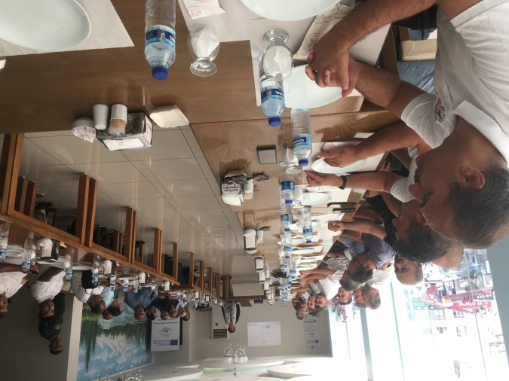
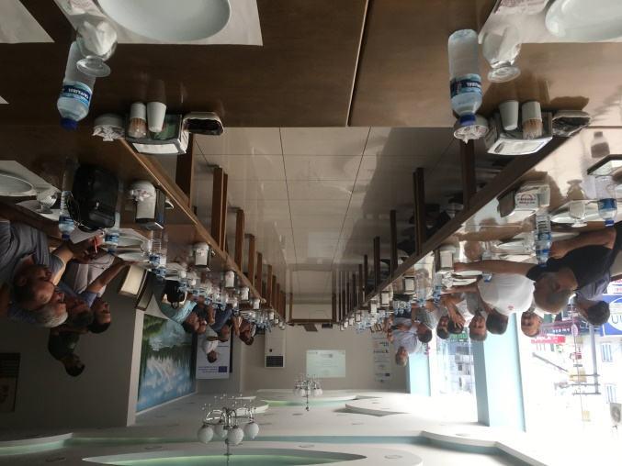
MA1 Promoting the Blue Career Path Platform –E1” Multiplier of the event activity hereby , Monday , August 30 , 2022 day Osmaniye Provincial National Education of the Directorate representatives , Erasmus+ strategic partnership project " Blue in economy Career of the Guidance results in Osmaniye Vocational education administrators and teachers , profession organizations representatives with shared . event , Participants on the field a were guided to explore the advantages that a career has to offer. them, Blue Erasmus program and Project in economy Career guidance presentation , Project scope , objectives and consortium and associated partners , Project of the results presentation and transferability , Blue Career way Platform , Blue in economy Online Education Course , Blue Career eMentoring program presentation done . Osmaniye Province National Education of the Directorate representatives of the participants your questions answer for were with them and the participants were able to identify possible future opportunities in this area according to their preferences. a job selection about your horizons expanding They were satisfied with this experience. More Then participants , Osmaniye Province National Education of the Directorate representatives with round table meetings by doing blue economy about detailed information owner they are
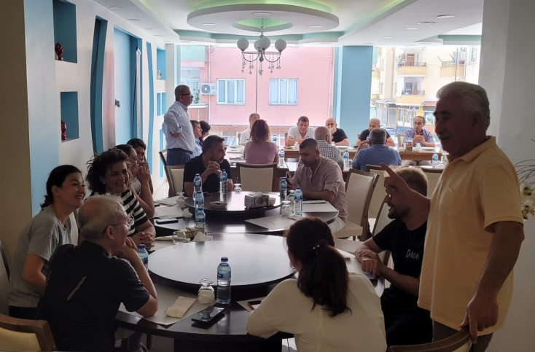
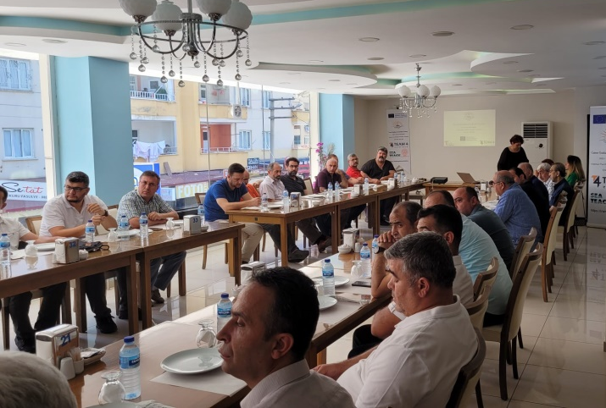
The BeBlue project is a partnership with Romania Asociatia TEAM 4 Excellence coordinator, Turkey - Osmaniye Provincial Directorate of National Education and Spain - Sea Teach organizations and emerged as a response to the lack of transparency of skills and qualifications responsible for labor market inefficiency in the blue economy. In addition, low labor mobility of "blue economy professionals" is also a problem facing workers in Europe. Interviews with stakeholders in the blue sector concluded that increasing the transparency of skills needed in relevant areas would be appropriate, achievable and feasible to improve labor market inefficiencies .

same time , the project Participants received professional guidance to access the blue economy courses we designed within the scope of the program and offered free of charge in English, Romanian, Spanish and Turkish on the online platform. They contain valuable information about each sector of the blue economy, where students can find which job offers fit their qualifications and interests. Provide guidance to VET teachers and trainers on maritime resources, courses and training opportunities education materials given .
Erasmus opportunities Follow the project page https://trainingclub.eu/beblue/ to keep up to date with the latest news .
Activity , Europe commission by ID 2020-1-RO01- KA202-080397 Financing Agreement It is part of the implementation plan of the "Career Guidance in the Blue Economy" project co-financed through

