April 2022, Press Release
BeBlue – Career Guidance in Blue Economy

The blue economy covers a wide range of established sectors (e.g. shipping, offshore oil&gas, coastal tourism) and emerging sectors (e.g. offshore renewables, biotechnology). These sectors are inter-related and jobs are available for job seekers to enter you to move across. In this context, there is the necessity of promoting economic growth, social inclusion and development of livelihoods, while protecting the environment and encouraging the sustainable initiatives in the ocean and coastal areas.
The BeBlue project developed by Association TEAM4Excellence from Romania, Sea Teach from Spain and Osmaniye Il Milli Egitim Mudurlugu from Turkey aims to strengthen the intra and inter sector mobility of vocational education and training (VET) learners from partner countries in the blue economy. The project is implemented with help from 15 other associated partners that contribute to reaching the target groups, to implement project tasks and to support the dissemination.
This partnership is a response to the lack of transparency of skills and qualifications, which is responsible for inefficiencies in the blue economy labour market. On top of that, the low labour mobility of “blue professionals” is also a problem that workers from Europe have to face. Interviews with blue stakeholders led to the conclusion that increasing the transparency of skills needed in the related fields would be suitable, achievable and feasible for improving the labour market inefficiencies.
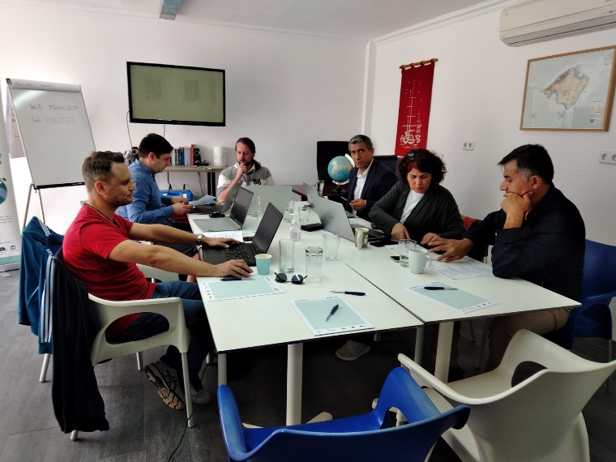
Between 18th – 22nd of April 2022, the 3 partners met in Cala d’Or, Mallorca, Spain for Learning, Training and Teaching Activities. During this meeting we shared our thoughts and practices about the solutions that could be implemented in order to help young people to obtain the necessary skills and career guidance in order to get employed into the sector of blue economy.
During 5 days, participants discussed about the ways to promote the blue careers to young people, educational tools and materials for their education in the blue economy field and how to help youth pursue a job in various blue economy sectors. Participants shared best practices in e-mentoring, along with feedback collected from their target groups. They also discussed about mentoring processes and the mentoring support platform which is being developed during this 2-year project.
Visit the BeBlue project webpage to learn more about the projects and its outstanding results.

